 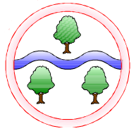

**Mathematics**

Multiplication and Division

Geometry: Shape

Operations Consolidation

Fractions

Statistics

**Computing**

E-Safety and Digital Literacy

Creating Media: Photo Editing

**English**

Fronted Adverbials

Subordinate Clauses

Using a wider range of conjunctions, adverbs and prepositions

Plan and compose different text types

Evaluate and edit

Using correct punctuation including inverted commas

**Art**

Exploring Still Life

Surfaces and Colours

**Design and Technology**

Designing, making and evaluating instruments

**Time Travellers**

Spring 1: Rock Stars

Spring 2: Essex Explorers

**History and Geography**

Human and Physical features

Map Skills

Types of Settlement

**Science**

How sound is made

How sound travels

Pitch

Volume

Observing and predicting

**RE**

Hinduism

Christianity

**Languages**

Four Friends

Language of the Month

**Music**

Listening to music

Composing

**PSHE**

Living in the Wider World: Money management, aspirations & the environment

**PE**

Swimming

Gymnastics

Handball

**Ghyllgrove Community Primary School**

Year 4 Spring