**Ghyllgrove P.E. Kits**

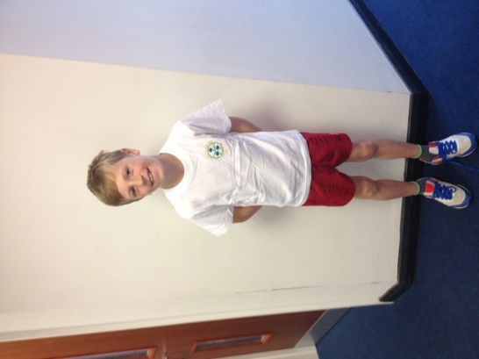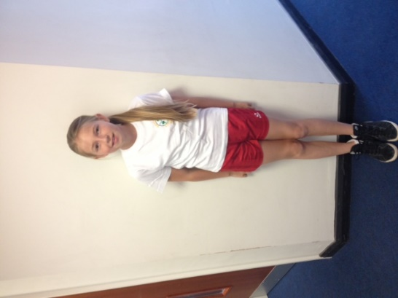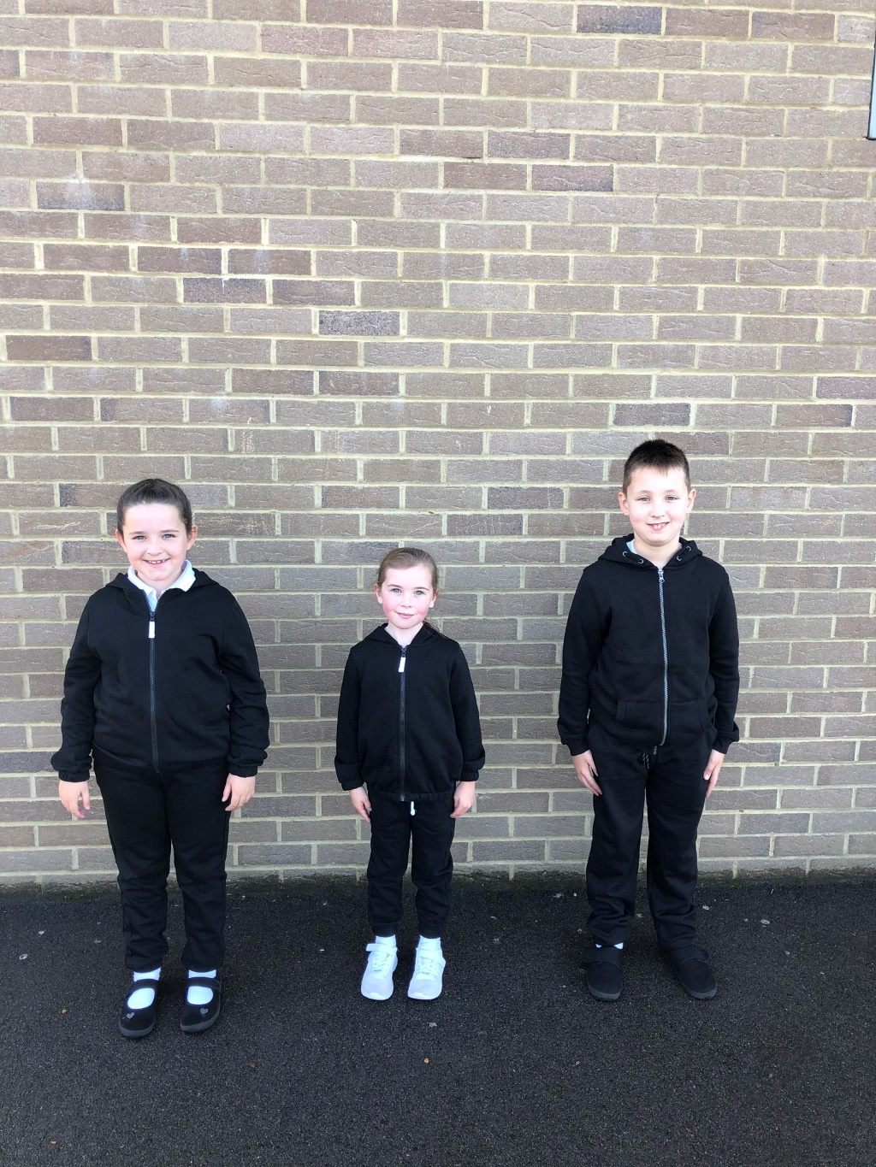

Our **PE Kit** consists of:

**- RED** shorts,

**- WHITE** T-Shirt

- Trainers or plimsolls

- Plain black tracksuit

- PE Bag (Labelled)