

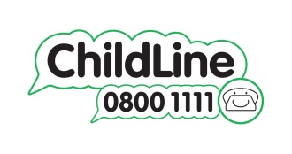**Child Friendly Safeguarding Policy**

**Need to talk?**

If you need to talk – we will listen. You can talk to any adult within the school, anyone you feel comfortable talking to will listen and help you.

If you do not want to talk you can always write it down and give it to a member of staff.

Or you can ring Childline.

All children deserve to feel….

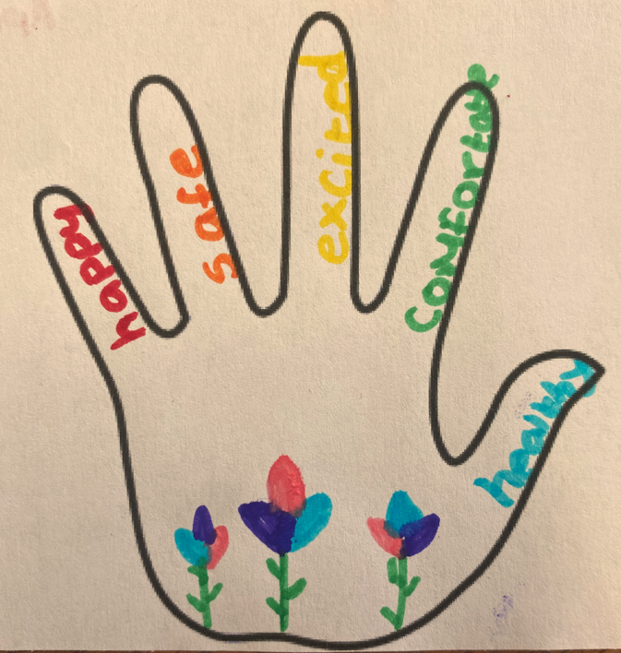

**What happens:**

Sometimes a member of staff at school will need to check things with Mrs Patmore.

There are times though when they may need to contact some other people for help. These may be children’s social care or police. There are lots of other people who support children and their families as well.

Staff will talk to you and explain all of this and you can always go and ask staff questions if you are unsure about anything.

**Safeguarding means:**

* Protect you from harm
* Make sure nothing stops you from being healthy and safe
* Make sure you are safely looked after
* Make sure you have the best opportunities and can grow up happy and successful

**How will we try to protect you?**

* We provide a safe and secure environment for you to learn in to become your best self
* We help to ensure that you remain safe, at home as well as at school
* We think it is important for you to know where to get help, if you are worried or unhappy about something
* We help you keep safe online