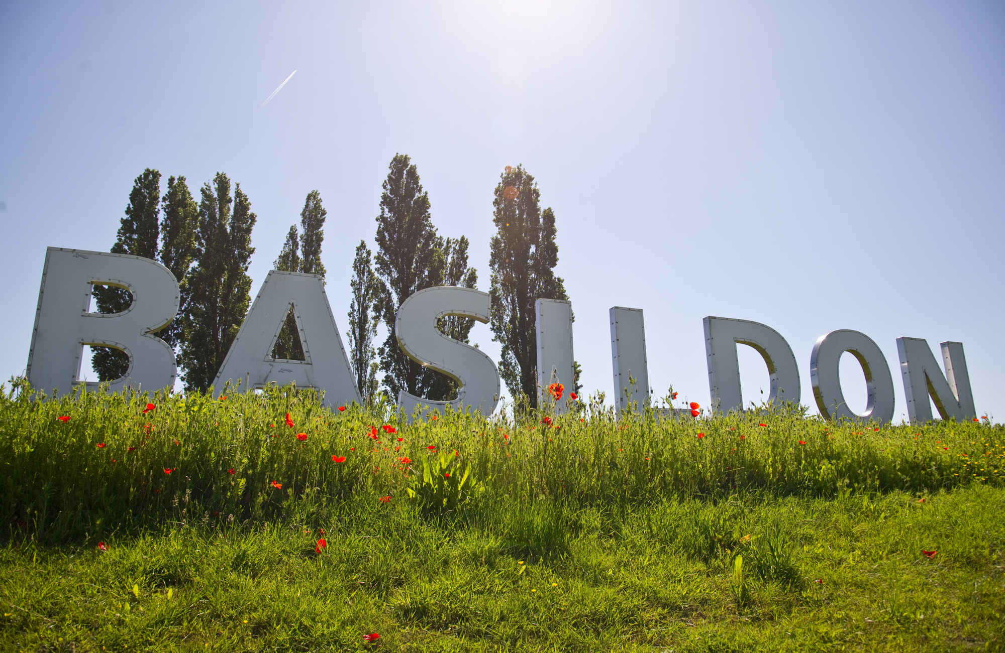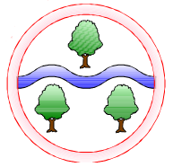

**Where We Live –** Exploring different types of vehicles old and modern.

**Whatever The Weather –** Studying the weather and how it changes through the seasons.

**Mathematics**

**Place Value**

Within 10

Within 20

**Addition and Subtraction**

Within 10

Within 20

Number bonds to 5 and 10

**Geometry**

2D and 3D shapes

**Computing**

Autumn 1: We are illustrators

Autumn 2: Directions and maps

**English**

**Reading**

A selection of Fiction and Non-Fiction texts

Read Write Inc Phonics

**Writing**

Using full stops

Using capital letters  
Finger spaces

Using ‘and’ to join two words

**Art**

Sketching  
Autumn 2: India Flint – artist study

**Design and Technology**

**History and Geography**Autumn 1:   
Events Beyond Living Memory

Geography skills and map work for the local area

Autumn 2:   
Human and physical geography

Weather and Seasons

**Science**Autumn 2:

Seasonal Changes and recording weather including rainfall and temperature.

**RE**

Christianity

**Language of the Month**

Sept: Lithuanian Oct: Polish

Nov: Turkish Dec: Romanian

**Music**

Pitch (high, low)

Ostinato (pattern)

Listen with concentration

**PSHE**

Autumn 1: Hygiene

Autumn 2: Meeting needs

**PE**

Autumn 1: Games

Autumn 2: Dance/Yoga

**Ghyllgrove Community Primary School**

Year 1 Autumn